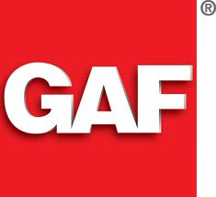

Grand Sequoia®

Lifetime Designer Shingles

"Great Value For A Rugged Wood Shake Look."
"Extra-large designs with over-sized tabs create a realistic wood shake look—at a fraction of the cost!"

The many layers of a Grand Sequoia® shingle
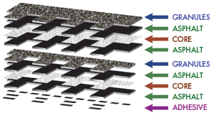

Affordable Luxury...
GAF Lifetime Designer shingles are only a fraction of the cost of traditional slate, wood shakes, or expensive metal roofing

Sophisticated Design...
Artisan-crafted shapes combined with oversized tabs and a dimensional design result in a sophisticated beauty unmatched by typical shingles

Natural Color Palette...
Specially-formulated color palette is designed to accentuate the shingle's natural appeal

High Performance...
Designed with Advanced Protection™ technology, which minimizes the use of natural resources while providing superior protection for your home (visit www.gaf.com/aps to learn more)

StainGuard ® Protection...
Helps assure the beauty of your roof against unsightly blue-green algae ²

Safer...
Class A fire listing from Underwriters Laboratories-the highest rating possible- and safer than wood shakes or some plastic/synthetic shingles, which carry only a Class C fire rating!

Stays In Place...
Dura Grip® adhesive seals each shingle tightly and reduces the risk of shingle blow-off. Shingles warranted to withstand winds up to 130 mph!¹

The Ultimate Peace Of Mind...
Lifetime ltd. transferable warranty with Smart Choice® Protection (non-prorated material and installation labor coverage) for the first ten years ²

Perfect Finishing Touch...
For the best look, use premium Timbertex® distinctive ridge cap shingles. (In the West, use high profile Ridglass® ridge cap shingles; Sequoia®/Canyon™ ridge cap shingles are also a good choice.)

