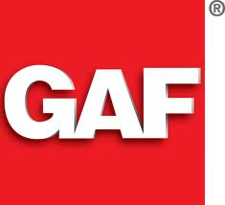

Slateline®

Designer Lifetime Shingles

"The Look Of Slate At A Fraction Of The Cost" "Bold shadow lines and tapered cut-outs create the appearance of depth and dimension"

The many layers of a Slateline® shingle
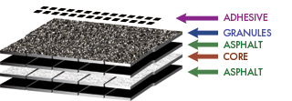

Affordable Luxury...
GAF Lifetime Designer shingles are only a fraction of the cost of traditional slate, wood shakes, or expensive metal roofing

Sophisticated Design...
Artisan-crafted shapes combined with oversized tabs and a dimensional design result in a sophisticated beauty unmatched by typical shingles

Natural Color Palette...
Specially-formulated color palette is designed to accentuate the shingle's natural appeal

High Performance...
Designed with Advanced Protection™ technology, which minimizes the use of natural resources while providing superior protection for your home (visit www.gaf.com/aps to learn more)

StainGuard ® Protection...
Helps assure the beauty of your roof against unsightly blue-green algae

Safer...
Class A fire listing from Underwriters Laboratories-the highest rating possible- and safer than wood shakes or some plastic/synthetic shingles, which carry only a Class C fire rating!

Stays In Place...
Dura Grip® adhesive seals each shingle tightly and reduces the risk of shingle blow-off. Shingles warranted to withstand winds up to 130 mph!¹

The Ultimate Peace Of Mind...
Lifetime ltd. transferable warranty with Smart Choice® Protection (non-prorated material and installation labor coverage) for the first ten years ²

Perfect Finishing Touch...
For the best look, use premium Timbertex® ridge cap shingles with StainGuard® protection. In the West, use Ridglass® ridge cap shingles.

